Model Answers Networking and Open Systems Exam 2000 2001

- A large network is composed of a number of subnetworks to which individual computers are connected. These subnetworks can be composed of transmission cables, switches, routers, and nodes, or may be other basic network types, i.e. network of servers.

- One view of the above network is a set of communications protocols organised in to layers or levels. The term “Network Architecture” is normally used to describe a layered network model.

You are a technical advisor to a group developing a layered network model for a new application. List the typical layer design issues which the group would have to consider when designing the model. Briefly comment on each issue in your list.
Application
(6 marks)

The following points should be covered to some degree in the answer:

The layer design issues that should/could be in the list are:

1/ Connection Establishment and Termination
- an entity in one layer must be able to establish a connections with an entity in the equivalent layer in the other machine
- either entity must be able to terminate the connection when the communication is complete
($23$ mark)
2/ Addressing
- if an entity can establish a connection with more than one entity, it must be able to decide which one to connect to by using individual addresses
($23$ mark)
3/ Data Transfer
- a connection may support data transfer in one direction (simplex), either direction but one at a time (half duplex), or both directions at once (full duplex)
($23$ mark)
4/ Message Ordering
- messages do not always arrive in the same order that they were sent (compare with delivery of letters)
($23$ Mark)
5/ Error Control
- messages must be delivered with a known probability of success
($23$ Mark)
{Section sub total $\text{10}3=313$}

6/ Controlling the Message Flow
- the receiver may not be able to accept messages as fast as the sender can transmit them
($23$ Mark)

7/ Sizes of Messages
- connections should have support for fragmenting and re-assembling large messages
($23$ Mark)

8/ Sharing
- connections may have to support several independent message flows
($23$ Mark)

9/ Routing
- several different connections may be available.
($23$ Mark)
{Section sub total $83=223$}
[[ Total $313+223=6$ ]]

- Describe a simple 3-Layer model and clearly distinguish between the three layers.
Hint: a diagram may form part of your answer.
Bookwork
(4 marks)

The following points should be covered to some degree in the answer:

Simple 3-Layer Model
Communications on a network can be organised into 3-layers:

1/ Application Layer
- exchanged data is processed by the user applications
($34$ Mark)

2/ Transport Layer
- data split into packets and re-assembled at destination, regardless of the application
($34$ Mark)

3/ Network Access Layer
- routing data between the computers, along the available media
($34$ Mark)
{Section sub total $94=214$}
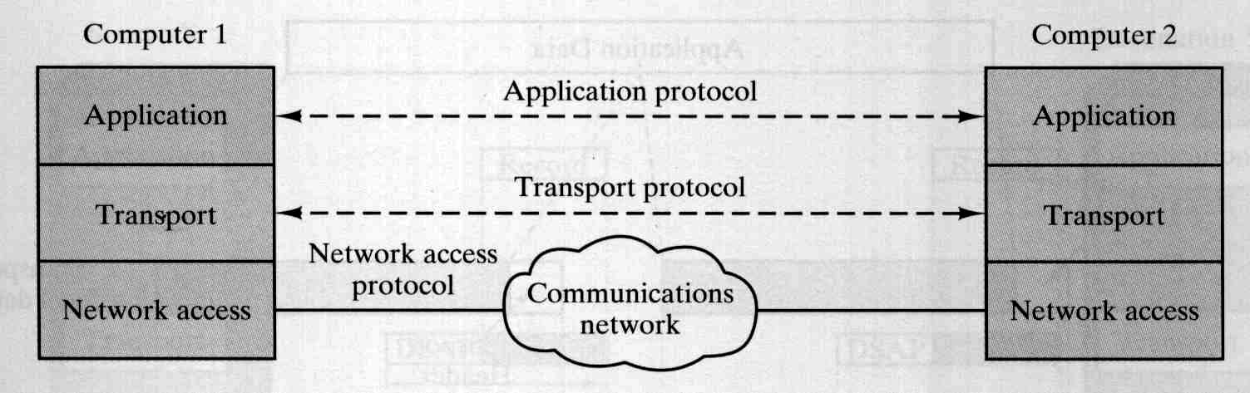
(1$34$ Marks)
{Section sub total $134$}
[[ Total $214+134=4$ ]]

- Data is transmitted on a network using either ‘circuit switching’ or ‘packet switching’.

Drawing on your knowledge of networked and open Systems, determine what in meant by the terms ‘circuit switching’ and ‘packet switching’.
Bookwork
(5 marks)

The following points should be covered to some degree in the answer:

1/ ‘circuit switching’
A physical circuit is established between two systems for the duration of the connection. Circuit switching: have to establish connection(s) before transmission and disconnect after data transfer; continuous transmission of data; sender/receiver work at same speed; connection-orientated network. They guarantee a fixed bit rate and delay variation.
(2$12$ Marks)
2/ ‘packet switching’
Data to be transmitted can be viewed as a stream of bits – the stream of bits is divided up by the sending system into blocks called “packets.” Switching nodes store the packets before retransmitting them. Packet switching: not fixed connections, destination stored within each packet; transmission delays as packets stored at nodes prior to forwarding; sender/receiver speed conversion; connectionless network.
(2$12$ Marks)
[[ Total $212+212=5$ ]]

- Circuit switching and packet switching networks can be said to be connection-orientated and connectionless services.

Compare and contrast connection-orientated and connectionless services.
Hint: You will be marked on your critique of the two services.
Critique
(5 marks)

The following points should be covered to some degree in the answer:

1/ connection-orientated services
A network supporting connection-oriented service is aware of connections between the end-systems. A connection is set up between two end-systems. The connection must be set up before data is exchanged; hence the service is aware of the end-systems it services. A connection-oriented network requires a channel to be established between the sender and receiver before any messages are transmitted. Examples of connection-oriented protocols include the telephone, TCP, and HTTP.

(1$12$ Marks)

2/ connectionless services
The service is connectionless, as the service does not have to beware of the other end-systems. The service just handles packets and posts them towards the final target end-system. The method does not have to set up a connection before the data is sent; the packets are sent from A to B and called “datagrams” as they are addresses to B. Connectionless implies a communications architecture that does not require the establishment of a session (connection) between two nodes before transmission can begin. The transmission of frames within a local area network (LAN), such as Ethernet, Token Ring and FDDI, is connectionless. UDP packets within a TCP/IP network are also connectionless.
(1$12$ Marks)

Contrasting, point to note: | connection-orientated services | connectionless services
Set up connection prior to transmission of data | YES | NO
Connection must be torn down after transmission of data | YES | NO
Data sent as “datagrams” | NO | YES
Each packet has address of destination station | Not required | Required
+ (2 Marks) for well presented/reasoned compare and contrast statements
[[ Total $112+112+2=5$ ]]

- A network constancy company is given a brief to investigate the requirements of a network. The brief states that the communication channel minimum bandwidth should be selected to support a datarate of 5000bits/sec.

- Comment on what is meant by minimum bandwidth.
Bookwork
(4 marks)

The following points should be covered to some degree in the answer:

Minimum Bandwidth is the smallest bandwidth that a signal requires when it is sent over a media in order that it produces a reasonable signal at the receiver. To allow for acceptable distortion the fundamental and first few harmonics are sufficient to transmit the data, hence the minimum bandwidth can be estimated after calculation of the fundamental and the third harmonic frequencies.
(4 Marks)

- Calculate the minimum bandwidth for a 5000bits/sec signal transmitted over a communication channel. The minimum bandwidth should be calculated for the worst-case sequence 101010. State any assumptions you make when performing the calculation.
Application
(6 marks)

The following calculation is a typical method of calculating minimum bandwidth:

5000bits/sec:

This is 1 bit every 1/5000 Sec.
or 0.2x10-3 sec or 0.2 milli-Sec (0.2ms)
(1 Marks)
Fundamental frequency only:
worst case 101010:
This means period (T) of “10” is 0.4ms
(1 Marks)
giving a fundamental frequency of
f=1/T which is fo = 1/0.4x10-3 = 2500Hz
(1 Marks)
has fundamental frequency fo = 2500Hz,
minimum bandwidth 0-2500Hz (considering only the fundamental)
(1 Marks)
{Section sub total $4$}

Fundamental and third harmonic:
Third harmonic f3 = 3xfo= 3x2500 = 7500Hz,

Final minimum bandwidth 0-7500Hz
(1 Marks)

Assumption: To allow for acceptable distortion the fundamental and first few harmonics are sufficient to transmit the data.
(1 Marks)
{Section sub total $2$}
[[ Total $4+2=6$ ]]

- Compare and contrast each of the following guided media communication technologies: twisted pair, coaxial cable, and fibre optic cable. State the most common applications for each of the guided media.
Hint: You will be marked on your critique of the three technologies.
Critique
(10 marks)

The following points should be covered to some degree in the answer:

1/ Guided Media - Twisted Pair
Simply two pieces of thin (1mm) copped wire twisted loosely together
- the twist reduces electrical interference between it, other twisted pairs and noise sources
Typical bandwidth is several Mbits/sec over several kilometres.
Used for both analogue and digital transmission.
Most common application is the telephone system.
(1 Marks)

2/ Guided Media - Coaxial cable
Similar to television aerial cable.
Bandwidth typically 10Mbits/sec over about 1Km, very good for preventing electrical interference.

Most common applications:
- television distribution
- long-distance telephone
- short-run computer links
- local area networks
(1 Marks)

3/ Guided Media –Fibre Optics
Light pulses from lasers or light emitting diodes are internally reflected down the fibre.
- pulses can take different times depending on the angle, and their colour composition and spread.
Very high bandwidth, currently 100-1000Mbits/sec up to 100Km.

Most common applications:
- long-haul, metropolitan trunks.
- local area networks.
(1 Marks)
{Section sub total $3$}

Fibre Optics v Coaxial Cable
Fibre optics has many advantages:
It has a much higher bandwidth
Gives much less attenuation
- fewer repeaters required on long lines (every 30km instead of 5km)
Not effected by power failure or surges, e/magnetic interference, corrosive chemicals in the air.
It is thin and lightweight
But, it is a newer technology:
- inherently unidirectional
- interfaces more expensive

(2 Marks)

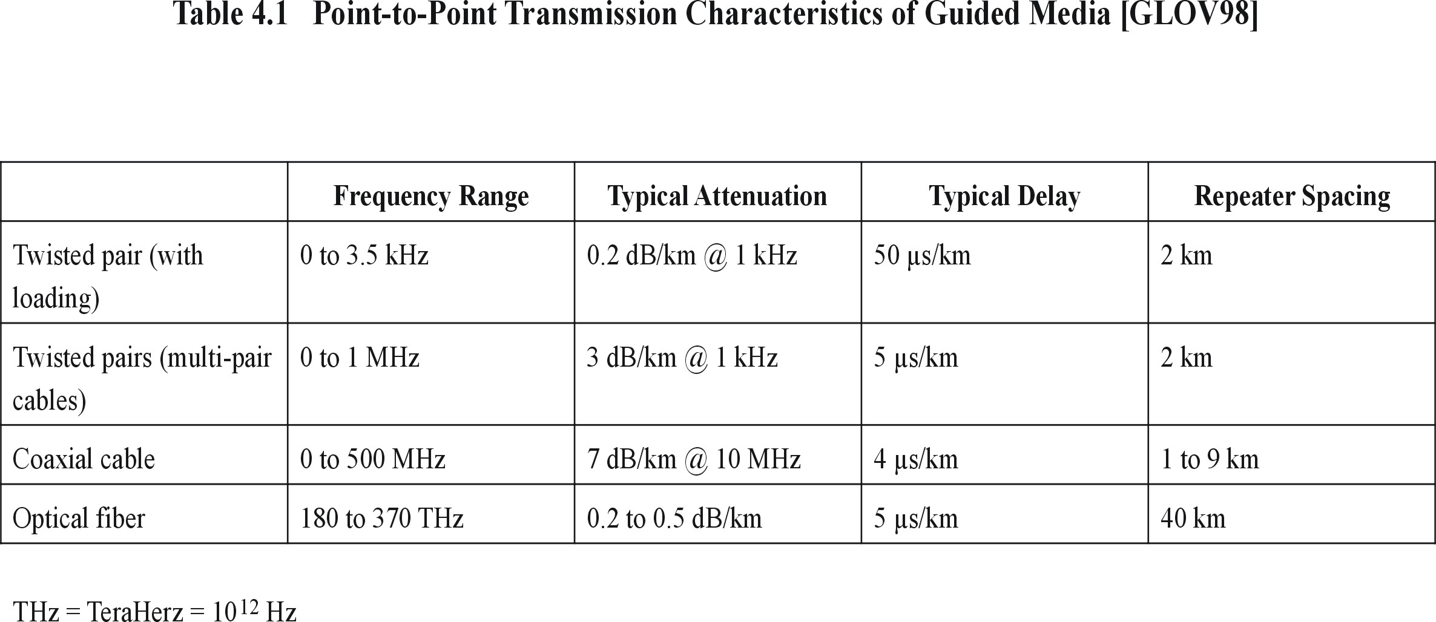
Contrast the following:
Most common applications
telephone system

telephone system

television distribution; long-distance telephone; short-run computer links; local area networks.
long-hau; metropolitan trunks;local area networks

+(5 Marks) for well presented/reasoned compare and contrast statements.
{Section sub total $7$}
[[ Total $3+7=\text{10}$ ]]

- Data is transmitted on a networked system from a source machine to a destination machine. The data is sent in two different formats and these two formats can be said to be the basic ‘transmission modes’ of a networked computer at the physical layer.

- The diagram below depicts one of the two ‘transmission modes’. Label all five items and brief state what function each item performs.
Bookwork
(6 marks)

The following points should be covered to some degree in the answer:

Item 1: Idle state
Function of Item 1: In the idle state no data is being transmitted and the receiver is not clocking in data. The receiver is waiting for the start bit to start sampling (clocking) in the data bits in the asynchronous frame.
(1 Marks)
Item 2: Odd or Even Parity bit
Function of Item 2: Parity bit enable one bit error detection to be carried out by the receiver.
(1 Marks)
Item 3: Idle state or next start bit
Function of Item 3: In the idle state no data is being transmitted and the receiver is not clocking in data. The receiver is waiting for the start bit to start sampling (clocking) in the data bits in the asynchronous frame.
(1 Marks)
Item 4: Start bit
Function of Item 4: The start bit tells the receiver to start clocking in the data in the asynchronous frame.
(1 Marks)
{Section sub total $4$}

Item 5: Stop bit
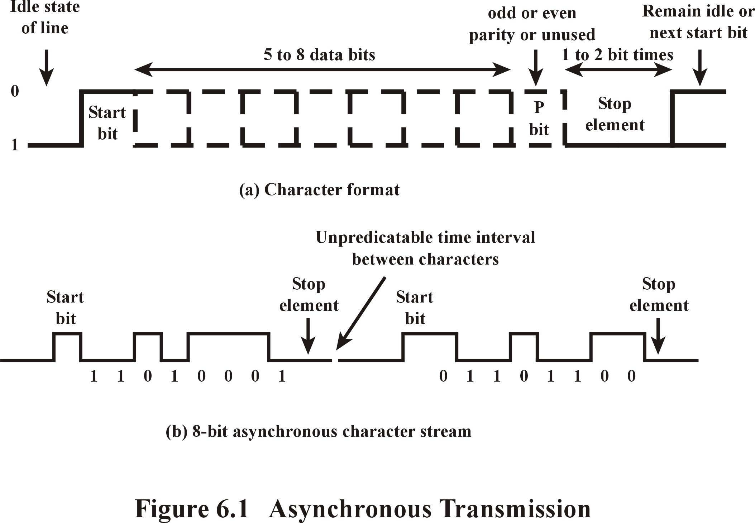
Function of Item 5: The stop bit tells the receiver that the asynchronous frame has ended and it stops clocking in data.
(1 Marks)
(1 Marks)
{Section sub total $2$}
[[ Total $4+2=6$ ]]

- A networking company is developing two new physical layer protocols that use two different format ‘transmission modes’. One format transmits data byte by byte; the other transmits blocks of data.

Identify which of the two ‘transmission modes’ you would use in each case and state why each was applicable for that application.
Application
(7 marks)

The following points should be covered to some degree in the answer:

Transmission Modes
Data is usually transmitted in fixed-length units:
    - 8-bits bytes for historical reasons
… in one of two modes:

One format transmits data byte by byte:

1/ asynchronous mode, where each data byte is sent independently of the other bytes in the message. Asynchronous transfer = Transfer in which each block (i.e. information character/s) is individually synchronised (usually by the use of start bits [or bytes, elements] and stop bits).

(3$12$Marks)
{Section sub total $312$}

One format transmits blocks of data:

2/ synchronous mode, where all data bytes follow each other in a large block of data. Synchronous transfer = Data transfer in which the time of occurrence of each signal representing a bit is related to a fixed time frame. A mode of transfer in which timing of all operations controlled by equally spaced signals of a clock. In the case of a transmitter and receiver - each would have a separate clock running at the same frequency.
(3$12$Marks)
{Section sub total $312$}
[[ Total $312+312=7$ ]]

- Data transmitted on a channel connected to the physical layer of networked systems is normally digitally encoded.

Compare and contrast the advantages of a digital data transmission.
Hint: You will be marked on your critique of the advantages of a digital data transmission.
Critique
(7 marks)

The following points should be covered to some degree in the answer:

Digital Data Transmission

Assessment of the advantages of a digital data transmission:

        - can correct/regenerate the data for attenuation/distortions along the media, and give lower error rates.
(2 Marks)
        - multimedia data (speech, data, music, images, fax etc) can be interspersed and so easily handled.
(1 Mark)
        - generally cheaper because less accuracy required (0/1 v analogue).
(1 Mark)
        - maintenance easier as the bits are received correctly or not.
(1 Mark)

NOTE: some media only propagate analogue signals optical fibre, unguided.
+ (2 Mark) for well presented/reasoned assessment.
[[ Total $7$ ]]

- In a networked system the 7-layer ISO OSI Reference Model - Transport layer provides a virtual communications channel that provides an efficient, reliable and cost effective data transport between source and destination applications (programs). Another view is that it enhances the Quality of Service that the Network layer provides.

- Drawing on your knowledge of the Transport layer draw up a critical appraisal of the services the OSI Transport layer provide.
Critique
(6 marks)

The following points should be covered to some degree in the answer:

- a (remote login) session might extend over several transport connections, or, with only occasional traffic, the transport connection may be disconnected and re-established later.
(1 Mark)

- the session layer provides a mechanism for handling a token, which could be used to co-ordinate the activities between two inter-communicating processes.
(1 Mark)

- Synchronisation/checkpoints can be set in long communications for efficient error recovery.
(1 Mark)
+ (3 Mark) for well presented/reasoned critical appraisal.
[[ Total $6$ ]]

- Name and briefly describe the main Quality of Service (QoS) parameters.
Bookwork
(10 marks)

The following points should be covered to some degree in the answer:
Q of S = Quality of Service. Packet delivery guarantees by the network architecture. Usually related to performance guarantees, such as bandwidth and delay. The Internet offers a best-effort delivery service, meaning that every effort is made to deliver a packet but delivery is not guaranteed.
(2 Mark)
Connection establishment delay (Q of S) = is the amount of time elapsing between a transport connection being requested and the confirmation being received by the user of the transport service.
(1 Mark)
{Section sub total $3$}

Connection establishment failure probability (Q of S) = is the chance of a connection NOT being established within the maximum establishment delay, e.g. due to network congestion, lack of table space or internal problems.
(1 Mark)

Throughput (Q of S) = parameter that measures the number of bytes of user data transferred per second, measured over some time interval.
(1 Mark)

Transit delay (Q of S) = measures the time between a message being sent by the transport user on the source machine and it being received by the transport user on the destination machine.
(1 Mark)

Residual error rate (Q of S) = measures the number of lost messages as a fraction of total sent. It could be said to be the error rate remaining after attempts at correction have been made.
(1Mark)

Protection (Q of S) = parameter provides a way for the transport user to specify interest in providing protection against unauthorised third parties reading or modifying the transmitted data (c.f. on the transport layer).
(1 Mark)

Priority (Q of S) = parameter provides a way for a transport user to indicate that some of its connections provide a faster or better service that others, i.e. a higher-priority connection takes precedence over a low-priority connection.
(1 Mark)

Resilience (Q of S) = parameter gives the probability of the transport layer spontaneously terminating a connection due to internal problems or congestion.
(1 Mark)
{Section sub total $7$}
[[ Total $3+7=\text{10}$ ]]

- The Transport layer is hieratically above the network layer. One of the functions the Network layer provides is to find the most efficient and resilient path between source and destination. Routing algorithms carry out this task.

A networking company has employed you as a consultant network designer. They have asked you to give advice on typical routing algorithms.

Excise you knowledge of routing algorithms and contrast several typical routing algorithms.
Note: You answer may include a list of typical routing algorithms with a brief description of how each performs its task.
Application
(4 marks)

The following points should be covered to some degree in the answer:

Routing Algorithms:

These algorithms try and find the most efficient and resilient path between source and destination and may user either Advance (static) routing:
- path fixed in advance on the basis of available routing information

OR Adaptive (dynamic) routing:
- path can be changed dynamically ending on current topology/traffic

Typical algorithms are:
- shortest path /multi-path / flooding
- centralised / hierarchical

A/ Static routing = or non-adaptive - does not base routing decisions on measurements or estimates of current traffic or topology. The choice of the route to use to get from I to J is computed in advance, off-line, and downloaded to the routers when the network is booted. The routing information is fixed.
($12$Mark)
B/ Dynamic routing = or adaptable in contrast to static or non-adaptable, change their routing decisions to reflect changes in the topology, and traffic flow. The routing information if nit fixed. Base routing decisions on measurements or estimates of current traffic or topology.
($12$Mark)
1/ Shortest path (routing) = metric that uses shortest geographic distance, e.g. shortest path length, i.e. may be measured in number of hops.
($12$Mark)
{Section sub total $112$}

2/ Multi-path (routing) = uses more than one outgoing path to retransmit the data.
($12$Mark)

3/ Flooding (routing) = routing in which every incoming packet is sent out on every outgoing line except the one it arrived on.
($12$Mark)

4/ Centralised (routing) = routing is carried out using a router routing table, the router is a centre point and the technique is then called centralised routing. The centralised router has a entry in the table for every other router. Can only be used on reasonable sized systems.
($12$Mark)

5/ Hierarchical (routing) = When the network grow to large for centralised routing a hierarchical method may be used as per the telephone network. The routers are divided into ‘regions,’ each router knows how to route in its own region. Data sent to a router not in the local region is sent via the best path through other regions to get to the local region, which contains the destination.
($12$Mark)
+ ($12$Marks) for well presented/reasoned contrast statements.
{Section sub total $212$}
[[ Total $112+212=4$ ]]

- The goal of computer security is to guard against and eliminate potential threats. A secure system should maintain the integrity, availability and privacy of data held in the system.

A company has employed you as a computer security advisor to give a set of brief seminars to a group of company staff on secure system.

- At the first seminar you brief the group on Accidental and Malicious data misuse/alteration.

Drawings on your knowledge of computer security discuss the difference between Accidental and Malicious data misuse/alteration.
Application
(6 marks)

The following points should be covered to some degree in the answer:

- Accidentally: a user’s application goes out of control and overwrites another
user’s memory/files/information – OR –you accidentally overwrite an existing
file with another file.
(3 Marks)

- Maliciously: a person reads/modifies data held about, or belonging to another
person.
(3 Marks)
[[ Total $6$ ]]

- At the second seminar you explain the different break-in methods.

Explain in general terms some of the well-known break-in methods.
Bookwork
(8 marks)

The following points should be covered to some degree in the answer:

Logged-on terminal
A user leaves a computer terminal vacant and leaves all the applications he was using running and does not log off when he/she leaves the computer.
(1$35$Marks)

Obvious passwords
The user utilises a simple or obvious password that can be easily found.
(1$35$Marks)
{Section sub total $265=315$}

Trap-doors
A deliberate back-way into a system; that was put in by (and know only to) the system developer(s) to allow them to get in if all else fails. Some of the Unix virus problems were introduced by students that accidentally found this way in.
(1$35$Marks)
Trojan horse
A piece of software that emulates the real input/login screens so that the user is unaware of anything abnormal - but in fact catches all passwords and dialogs etc.
(1$35$Marks)
Trial & Error
Trying any possible selection/combination of characters to get through a login-password process or trying different words for each step –login then password.
(1$35$Marks)
{Section sub total $395=445$}
[[ Total $315+445=8$ ]]

- In the third seminar you introduce the group to private key and a public key systems.

Compare and contrast private key and public key systems.
Hint: You will be marked on your critique of private key and a public key system.
Critique
(6 marks)

The following points should be covered to some degree in the answer:

- Private key systems

  - The encryption/decryption keys are usually the same and kept secret. The general public has no access to either the encryption key or the decryption key.
(3 Marks)

- Public key systems

The encryption key is broadcast (so known by everyone - public), only the receiver knows the decryption key – private. Hence, only the receiver can decrypt the Cypertext correctly as he/she is the only one who has both key.
(3 Marks)
[[ Total 6 ]]

